What a great first month of school we had! I want to thank you as we move forward into our Grade One year. To continue our success with home and school communication, please send back message bags daily in case of any important information coming to and/or from school. –Ms. J. Brine

**What are we learning this month?**

**Reading –** We will continue focusing on reading behaviours and strategies to help us think about what is happening in our stories as well as focusing on books that are at our just right (not too hard, not too easy) level.

**Writing** – We will continue to write about real life events. Students are

encouraged to think about something they did and tell their stories through pictures and words.

**Math** – We are finishing up our first unit on numbers to 20. Next we will be focusing on patterning and geometry (sorting and naming attributes of 2-D and 3-D shapes).

# Happy Thanksgiving!

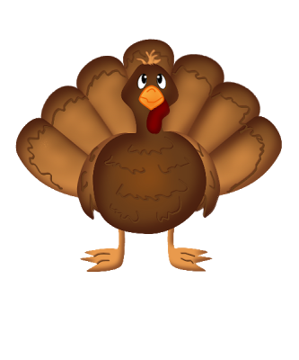

#### Specialist Schedule

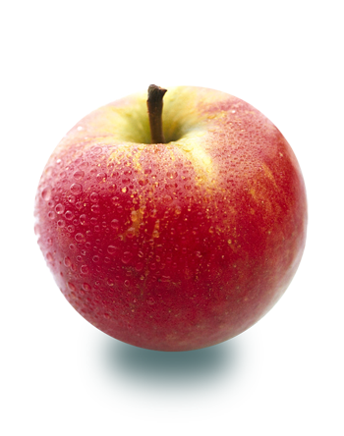

* October 10 – Thanksgiving - No School
* October 11 – Bus Evacuation Drill
* October 20 – Picture Retakes
* October 27 – Halloween Howl 6:30 – 8pm
* October 28 – Conference Day – No School
* October 31– Ice Cream Social



##### Library

Ms. LaChance

##### Music

Ms. Croft

Phys. Ed.

Mr. Elliott

Grade One Brine – October 3rd, 2016

October Newsletter



Thursday

Monday and Wednesday

Tuesday and Friday

### Upcoming Dates

Our home reading program is now underway! Your child has been selecting just right books from their classroom bag of books to take home each night. In order for your child to take home a new book they must bring back the one from the night before. Thank you for your support with reading to and with your child!

Cafeteria Orders



###### Email: [jennifer.brine@hrsb.ca](mailto:jennifer.brine@hrsb.ca)

**Phone:** 902-889-4301 ext 1701307

**Website:** gradeonebrine.weebly.com

Remind and FreshGrade

Orders can now be placed online. For any in-school orders, please send in money with the order and your child’s name in a sealed baggie. First thing in the morning your child will place the baggie in our classroom cafeteria basket. Recess snacks can be purchased from the cafeteria cart that comes down the lower elementary wing.



# Contact Info

As always, I encourage questions and comments. Please continue to use any of the following ways to contact me:

## Home Reading

Thank you for your patience with these apps as I work with them this year. If you haven’t yet subscribed and need a new copy of the information/permission forms please let me know. FreshGrade will officially be up and running this month so be sure to check-in for updates on your child’s learning!