**We had a great October with lots of learning involved. Here are some areas we’ll be focusing on in November:**

**Reading –** We will focus on using the strategies we’ve learned while reading independently and with a partner. We are asking ourselves questions to make sure a word we’ve read looks right, sounds right and makes sense!

**Writing –** We will continue to write stories about events in our lives. We are incorporating different ways of doing this by writing letters and lists.

**Math –** We are putting a focus back onto numbers 1-20 this month. We will be representing numbers to 20 in a variety of ways by using different manipulatives, showing a number in 2 parts, and estimating quantities.

#### Specialist Schedule

Phys. Ed.

Mr. Elliott

##### Music

Ms. Croft

##### Library

Ms. LaChance

Thursday

Tuesday and Friday

Monday and Wednesday

# November is here!



* November 10 – Remembrance Day Ceremony
* November 11 – Remembrance Day, No school
* November 14 – No school, Assessment/ Eval. Day
* November 22 – Report Cards go home
* December 1 – No School/ Parent Teacher Interviews
* December 13 – P-2 Christmas Concerts

Grade One Brine – November 4th, 2016

November Newsletter

### Upcoming Dates

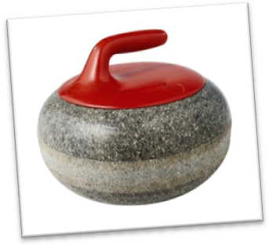

Exciting news! Through Writer’s Workshop the students in our class know I am actively involved in curling. The students will be able to see what it’s all about later this month. Home and School is bringing in Rocks & Rings for 3 days in November for Phys. Ed

class. It is a unique indoor floor curling program with special equipment to provide a

true curling experience without ice.

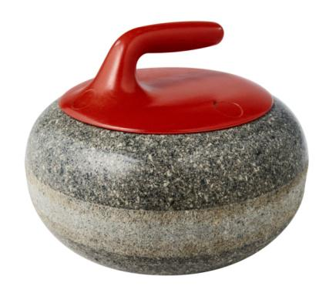

Rocks & Rings

Scholastic Book Orders

I’ll be sending home a few extra book orders for the upcoming months as there are many holiday books coming out. Please let me know if I can arrange for the books to go home another way if they are ordered as gifts for your children!

Thank you for all of the food donations for We Scare Hunger! Our class did extremely well and OPA brought in 1100 lbs. of food for our local food bank!

Thank you for sending in message bags on a daily basis. This helps to ensure information, just right reading books, bus notes, cafeteria money, etc. are going where they need to every day!

## **THANKS!**

###### Email: [jennifer.brine@hrsb.ca](mailto:jennifer.brine@hrsb.ca)

###### Phone: 902-889-4301 ext 7101307

###### Website: weebly.com/gradeonebrine

# Contact Info